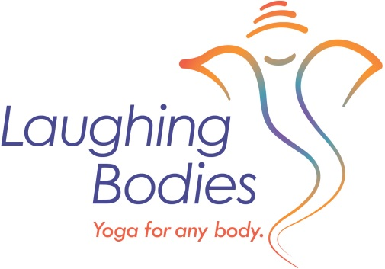
The full fee for TT/Yoga Immersion 2019 includes 4 months of on line training and 8 twenty hour weekends. The fee is between $2495-$2850.
Payment plans are available and can be made online through PayPal or by check.
Option to add on a fall retreat at the Gray Bear Retreat Center, October 4th-6th is also available for those who are registered in the 2019 Teacher Training.

Early Bird: Option 1 & 2 available until October 31st.
Option 1: $2495 Pay full amount in one payment by check. Due by October 31st, 2019

Option 2 Payment plan: $2750: $500 deposit, paid by check due by October 31st, 2019 with payment plan in place: Payment plan is $375 per month beginning November 1st, 2019 for six months.
Option 3 & 4 available until December 15th, 2019
Option 3: $2695: Pay full amount in one payment by December 15th, 2019
Option 4: Late Registration: $2850: $600 deposit by December 15th, 2019
Payment plan is $450 per month beginning Jan. 1st, 2020 for five months.

Add on Fall Retreat at the Gray Bear Retreat Center: October 4th-6th, 2019 (80 miles south of Nashville.)
This retreat is not officially part of the Teacher Training but the retreat can be used for 20 hours towards your Teacher Training. It is a good option so as if you miss any of the scheduled weekends in Crossville you have these hours to use towards your 200 hour certificate.
Discount is only available for those who have paid for 2019 training in full or have put down their $500 deposit and have a signed payment plan in place.
The full retreat cost would only be $350. Gray Bear usually sells out, so if you are interested in attending Gray Bear this year, please let me know right away. Also, note you do not have to come to this retreat to participate in the Teacher Training/Yoga immersion – this is just an additional offering.

